Attachment H – Sampling Toolkit

H.i: Recalled Water Cooler List

USEPA’s Water Cooler Recall List
Tables from EPA’s 3Ts for Reducing Lead in Drinking Water in Schools Revised Technical Guidance
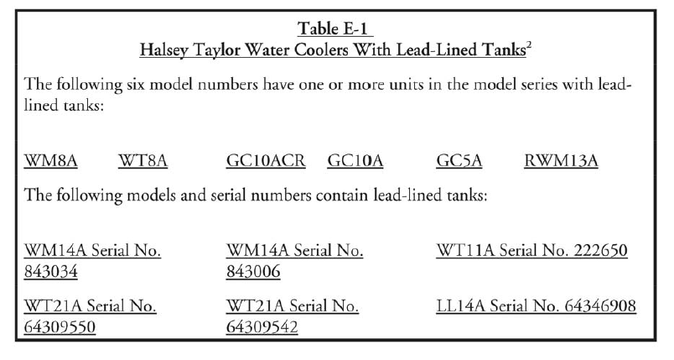
2Based upon an analysis of 22 water coolers at a US Navy facility and subsequent data obtained by EPA, EPA believes the most serious cooler contamination problems are associated with water coolers that have lead-lined tanks.

Per EPA’s 3Ts for Reducing Lead in Drinking Water in Schools Revised Technical Guidance, a company formerly associated with Halsey Taylor, Scotsman Ice Systems, has assumed responsibility for replacement of lead-line coolers previously marketed by Halsey Taylor. See below for the address of Scotsman Ice Systems.

Scotsman Ice Systems
775 Corporate Woods Parkway
Vernon Hills, IL 60061
PH: (800) SCOTSMAN or 800-726-8762
PH: (847) 215-4500

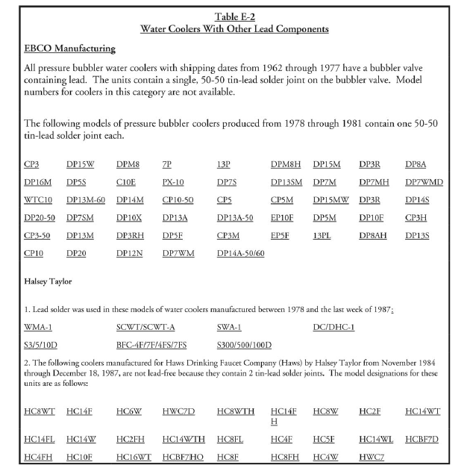
.

United States Environmental Protection Agency 3Ts for Reducing Lead in Drinking Water in Schools

H.ii: Ice Machine Sample Collection Procedure

Sample Collection Procedures:

Initial Screening Sample 1E
- Fill a 250 mL or larger, wide-mouthed bottle or other container provided by the laboratory at least three- quarters full of ice. Do not touch the ice with your hands. Use the non-metal scoop or disposable plastic gloves provided by the laboratory to place the ice in the container.

- If the lead level in Sample 1E exceeds 15 µg/L (ppb), collect a follow-up sample to determine if the source of the lead is the plumbing or the ice machine itself.

Follow-Up Sample 2E
- Disconnect the ice machine from the plumbing and look for a screen at the inlet. Remove the screen. If debris is present, forward a sample of the debris to the laboratory for analysis and clean out the remaining debris. The laboratory will determine whether lead solder is present. Clean the screen routinely to avoid accumulations of debris.

- Collect the sample from the disconnected plumbing as close to the ice machine as possible. Fill the sample container with 250 mL of water. If no outlet is available, contact the ice machine manufacturer for recommendations that will minimize disruption of existing plumbing. Adding outlets or valves could add new sources of lead to the plumbing, even if the new devices are lead-free and meet NSF Standard 61, section 8. If a sample outlet or valve is available, collect the sample immediately after opening the outlet or valve.
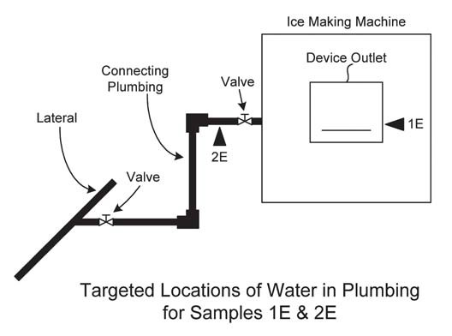

United States Environmental Protection Agency 3Ts for Reducing Lead in Drinking Water in Schools

H.iii: School Wide Flushing Procedure

Each drinking water outlet should be flushed individually; flushing a toilet will not flush your water fountains. All flushing should be recorded in the Flushing Log (Attachment E) for each school and completed prior to sampling to allow the required stagnation time.

- Locate the faucet furthest away from the service line on each wing and floor of the building, open the faucets wide, and let the water run for 10 minutes. This 10-minute time frame is considered adequate for most buildings.

- Open valves at all drinking water fountains without refrigeration units and let the water run for roughly 30 seconds to one minute, or until cold.

- Let the water run on all refrigerated water fountains for 15 minutes.

- Open all kitchen faucets (and other faucets where water will be used for drinking and/or food preparation) and let the water run for 30 seconds to one minute, or until cold.

United States Environmental Protection Agency 3Ts for Reducing Lead in Drinking Water in Schools

H.iv: Sampling Event Checklist
To be completed the day of sampling

Before Beginning Sampling:
- Review and Sign QAPP.
- Review School packet prior to sampling- including floor plan with sample locations, water outlet inventory including all outlets to be sampled, filter inventory including which drinking water outlets that have filters, and if applicable pre-sampling event flushing schedule including which outlets were flushed, the duration of flushing, and when they were flushed.
- Perform a walk-through of the facility prior to sampling. Identify all outlets to be sampled, and label each outlet with its unique sample location code as it is found in the water outlet inventory.
- Verify that the water has been stagnant for at least 8 hours, but no longer than 48 hours. If the stagnation time has not been met, the sampling will have to be rescheduled.

Sampling:
- Prepare a Field Blank.
- Start sampling at the outlet closest to the point of entry. Follow the sampling order established to follow the flow of cold water throughout the building.
- For each building being sampled record the time that sampling begins.
- Leave all aerators/screens and filters in place.
- Wearing gloves, collect samples into a 250 ml pre-cleaned wide-mouth bottle.
- Record the time each sample is collected.
- If follow-up flush samples are being collected, record the duration of the flush.
- Label all Follow-Up Flush Samples with “FLUSH” after their unique sample location code. (e.g. WHS-1FL-DW and WHS -1FL-DW-FLUSH)
- AFTER all other samples have been collected, for follow-up flush sampling, collect fifteen minute flushed samples from water coolers.
- Indicate on the Chain of Custody (COC) if the outlet is leaking, the water is discolored, the outlet is not working, or the outlet has a filter.

After Sampling:
- Record the time that sampling ends.
- Document and sign the COC.
- Count sampling bottles to make sure all water outlets on the water outlet inventory were sampled.

Project Officer:
Print Name Signature Date

Sampler:
Print Name Signature Date

H.v: Sample Signs

WATER TESTING IN PROGRESS
PLEASE DO NOT USE ANY WATER SOURCES – SINKS, FOUNTAINS, TOILETS, ETC.

DO NOT DRINK
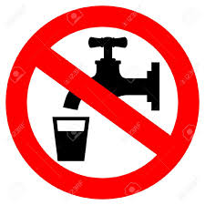
SAFE FOR HANDWASHING

H.vi: School Sampling Package Review Checklist

Review performed by: (Name/Title)_______________________________ Date: __________

Name and certification number of the NJ Certified Laboratory who performed the analytical testing:

Name: ______________________________________ Certification Number: ______________

- QAPP signed by all parties involved in sampling (Program Manager, Project Manager, Individual School Project Officers, Laboratory Manager, Laboratory QA Officer):Y or N
If N, obtain.

- Completed Plumbing Profile (Attachment B): Y or N
If N, provide details on what is missing:

If Y, should include:
- What is the material of service line: Y or N
  - Is the school served by a lead service line? Y , N , or Unknown
    - Must provide documentation for either Y or N answer. If Unknown, provide the plan for getting this information.
    - What is the material of potable water pipes: Y, N , or Unknown
  - Was lead solder used in the plumbing system? Y , N , or Unknown. If Unknown, provide the plan for getting this information (i.e. conduct lead swab checks on solder throughout the building).
  - Are brass fittings, faucets, or valves used in the drinking water system? Y or N
- Determined the Make and Model of Drinking Water Fountains/Water Coolers:
Y or N
  - Checked all of the drinking water fountains and coolers against the EPA list of recalled fountains: Y or N
    - If Y, any fountains that were on the list were taken out of service and the information was recorded in the school’s file.
- Identified areas deviating from normal usage in the drinking water system: Y or N
  - If Y, identify where. Verify that these areas were flushed properly.
- Are any outlets out-of-service: Y or N
  - If Y, identify where. Verify that these areas are still out of service. If permanently out of service, verify that theses outlets are planned to be decommissioned or replaced and if being replaced they will be sampled when placed in service. If temporarily out of service, verify that these outlets will be sampled when they are placed back in service.
- Have any plumbing repairs and replacements been performed within the last year: Y or N
  - If Y, identify where.

- Is Water Outlet Inventory (Attachment C) for the school completed with all information filled in? Y or N
If N, provide details on what is missing.

- Is the Filter Inventory (Attachment D) thoroughly completed: Y or N
If N, provide details on what is missing.

- Is the Flushing Log (Attachment E) thoroughly completed: Y, N or NA
Only applicable for facilities or specific locations in a facility that are not routinely used (e.g. concession stands) or deviate from normal usage (e.g. buildings closed for holiday break).
If Y, does it include duration and location of flushes? Y or N
If N, provide details.

- Is there a completed laboratory report & data package for each sampling event including Chain of Custody sheets, field notes, results report and Excel spreadsheet: Y or N
If N, provide details on what is missing.

Laboratory Report & Data Package Review

- Is the Laboratory Report & Data Package complete: Y or N
  - If N, provide details on what is missing and contact lab if necessary.

- Does the number of samples on the results report from the laboratory match the number of samples on the Chain of Custody? Y or N
  - If N, identify which sample(s) are missing. Add these sampling locations to the Follow-Up Sampling list.

- Is there a field blank? Y or N

- Are results reported in units of µg/l or ppb? Y or N
  - If N, remind lab to report results as µg/l or ppb.

- Are results reported to at least 3 significant figures? Y or N
  - If N, contact lab.

- Are there results above 100 µg/l? Y or N
  - If Y, compare the result on the Microsoft Excel spreadsheet with the result of the laboratory report. Both results should be identical. If the results do not agree, call the laboratory to verify the correct result.

- Compared the field/Chain of Custody notes to the sampling results? Y or N
  - If Y, are there any notes and sampling results that indicates a outlet needs to be re-sampled? Add these sampling locations to the Follow-Up Sampling list. (i.e. notes indicate outlet was leaking or water was discolored)

- Are there outlets that could not be sampled because they were not operational? Y or N
  - If Y, outlets will be need to be sampled as part of follow-up sampling. Add these outlets on the Follow-Up Sampling list.

- Are there sample codes not identified on the Key Code? Y or N
  - If Y, contact sample collector and individual school coordinator to identify.

- Verified that water outlets requiring pre-stagnant flushing were properly flushed: Y or N
  - Are there outlets that were sampled and after reviewing the field notes it is apparent they required pre-stagnant flushing but were not flushed? Y or N
  - If Y, these outlets need to be resampled as part of follow-up sampling. Add these outlets on the Follow-up sampling list.

- Compared initial first draw samples with follow-up flush samples (if collected): Y or N

- Are there outlets with an elevated initial first draw sample? Y or N
  - If Y, was a follow-up flush sample taken at these outlets? Y or N
If N, these outlets need sampled follow-up flush sample taken as part of the follow-up sampling. Add these outlets to the Follow-up Sampling list.

- Are there any outlets with follow-up flush sample results greater than the first draw sample results? Y or N
  - If Y, identify the internal plumbing material using the school’s plumbing profile.

- Match up the filters with the exact locations they are installed using the school’s filter inventory. Determine the following:
  - Exact date installed: Y, N, or Unknown
  - If N, return to location and identify.
  - If Unknown, assume the filter will need to be replaced.

H.vii: FOLLOW-UP SAMPLING INVENTORY

School Name__________________________________________________________________
Individual School Project Officer: ________________________________________________
Date Completed: __________________

SAMPLE ID/  LOCATION | REASON FOR FOLLOW-UP SAMPLING* | DATE RESAMPLED

H.viii: FOUNTAINS / DRINKING WATER COOLERS ON EPA’S RECALL LIST

School Name__________________________________________________________________
Individual School Project Officer: _______________________________________________
Date Completed: __________________

SAMPLE ID/  LOCATION | MAKE | MODEL | TAKEN OUT OF SERVICE  (DATE) | INITIALS

If N/A, provide signature below indicating that the school does not have any drinking water fountains/water coolers on the EPA Recall list.
____________________________________________ Date__________________________

H.ix: OUTLETS WITH FILTERS INSTALLED - RESULTS

School Name_________________________________________________________________
Individual School Project Officer: _______________________________________________
Date Completed: __________________

SAMPLE ID/  LOCATION | FILTER |  | Results (µg/l)  with current filter | Results (μg/l) without filter | Results (µg/l)  After new filter
 | Make | Model

H.x_ Data Review Summary

School: ________________________________________________
Date Sampled: __________________________________________
Individual School Project Officer: _____________________________________

- Verify number of samples.
  - Make sure there are results for each sample taken.
Number of outlets sampled: ______________________
Number of initial first draw: _________________________
Number of follow-up flush: ___________________

- Confirm all results are reported with no less than three significant figures and are in units of µg/l or ppb.

- Confirm follow-up flush samples are collected at all water outlets that require a flush sample.

Number of samples ≥15.5 µg/l initial first draw: ___________________
Number of samples ≥15.5 µg/l follow-up flush: ___________________
Total Number of samples ≥15.5µg/l: _________________

For samples ≥15.5 µg/l :
- Compare initial first draw samples with follow-up flush samples.

Number of outlets with decreased result between initial first draw and follow-up flush (≥ 15.5 µg/l and now < 15.5 ppb): __________
Number of outlets increased between initial first draw and follow-up flush (< 15.5 µg/l and now ≥ 15.5 µg/l):____________
Number of outlets that remained ≥15.5 µg/l (both results > 15.5 µg/l):_____________

- Verify follow-up flush samples that are greater than the initial first draw sample.
  - Check field notes and chain of custody for notes on the collection of these samples.
  - Compare the results on the laboratory reports with those on the Microsoft Excel spreadsheet.

- Verify results > 100 µg/l
  - Compare the result on the Microsoft Excel spreadsheet with the result of the laboratory report. Both results should be identical. If the results do not agree, call the laboratory to verify the correct result.
  - The laboratory reports must indicate if a sample required dilution. Compare the laboratory report to the Microsoft Excel spreadsheet to verify that any diluted samples were indicated as such on the spreadsheet.

- Verify sample results with field notes and chain of custody.
  - Use the field/ chain of custody notes to provide insight on what may have caused certain high results.

The following information is based on field notes and the chain of custody:

Number of drinking water outlets not sampled: __________________________
Sample ID of outlets that do not work/broken and were not sampled: ______________________
______________________________________________________________________________
______________________________________________________________________________

Number of outlets leaking/dripping (not repaired): ________________________
Sample ID of outlets leaking/dripping: ______________________________________________
______________________________________________________________________________
______________________________________________________________________________

Number of outlets with low pressure/slow flow: __________________
Sample ID of outlets with low pressure/slow flow: _____________________________________
______________________________________________________________________________
______________________________________________________________________________

Number, description, and Sample ID of other outlet issues (i.e. color, odor, plumbing turned off, etc.):_________________________________________________________________________
______________________________________________________________________________
______________________________________________________________________________
______________________________________________________________________________
______________________________________________________________________________

- Verify the water outlets requiring pre-sampling flushing were flushed.
  - Check the flushing log located in the school package to verify that outlets deviating from normal usage were flushed properly prior to sampling.

- Verify drinking water outlets with Filters.
  - Use the filter inventory in the school package to verify whether drinking water outlets have a filter.

- Verify unknown sample codes.
  - Make sure that ALL sample IDs used are included in the District’s outlet coding list.
  - Identify all sample IDs that are not listed on the coding list.

Additional information: __________________________________________________________
______________________________________________________________________________
______________________________________________________________________________
______________________________________________________________________________

